Project Report

# INTRODUCTION

* 1. Project Overview

The project titled **"Plugging into the Future: An Exploration of Electricity Consumption Patterns Using Tableau"** focuses on analysing electricity usage trends through interactive data visualizations. Using Tableau, the project explores electricity consumption across different dimensions — including time of day, seasons, and economic sectors (residential, commercial, industrial).

By visualizing large sets of electricity usage data, the project provides stakeholders with a clear understanding of when and where electricity demand is highest, how it varies over time, and how different sectors contribute to overall consumption. These visualizations make complex data more accessible and actionable for users ranging from utility providers to policymakers and consumers.

* 1. Purpose

The primary purpose of this project is to enable data-driven decision-making in the energy sector. By uncovering patterns in electricity consumption, the project aims to:

* Help utility companies improve grid management and load balancing.
* Assist policymakers in planning and implementing energy efficiency initiatives.
* Guide consumers toward smarter and more sustainable energy usage.
* Support the integration of renewable energy sources by anticipating demand.
* Identify opportunities for conservation within specific economic sectors.

# IDEATION PHASE

* 1. Problem Statement

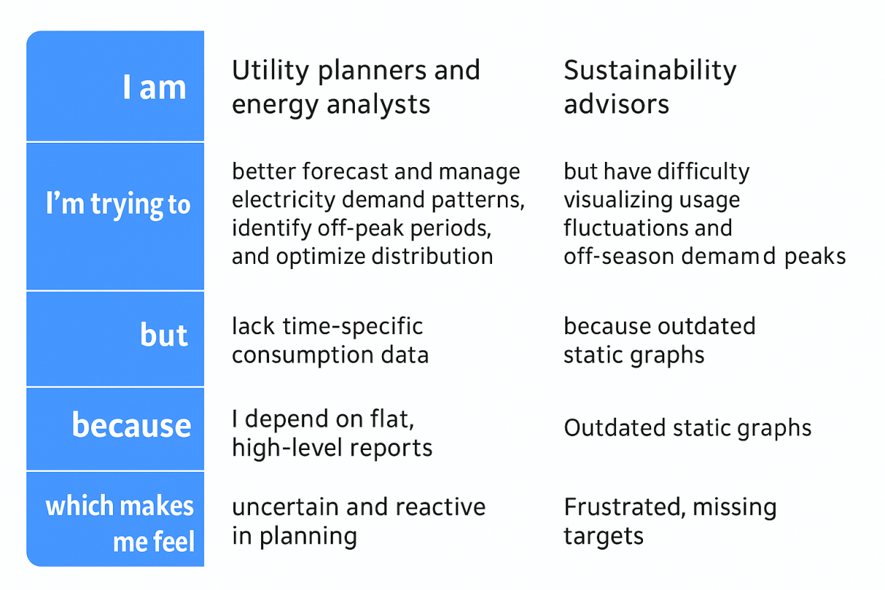

* 1. Empathy Map Canvas

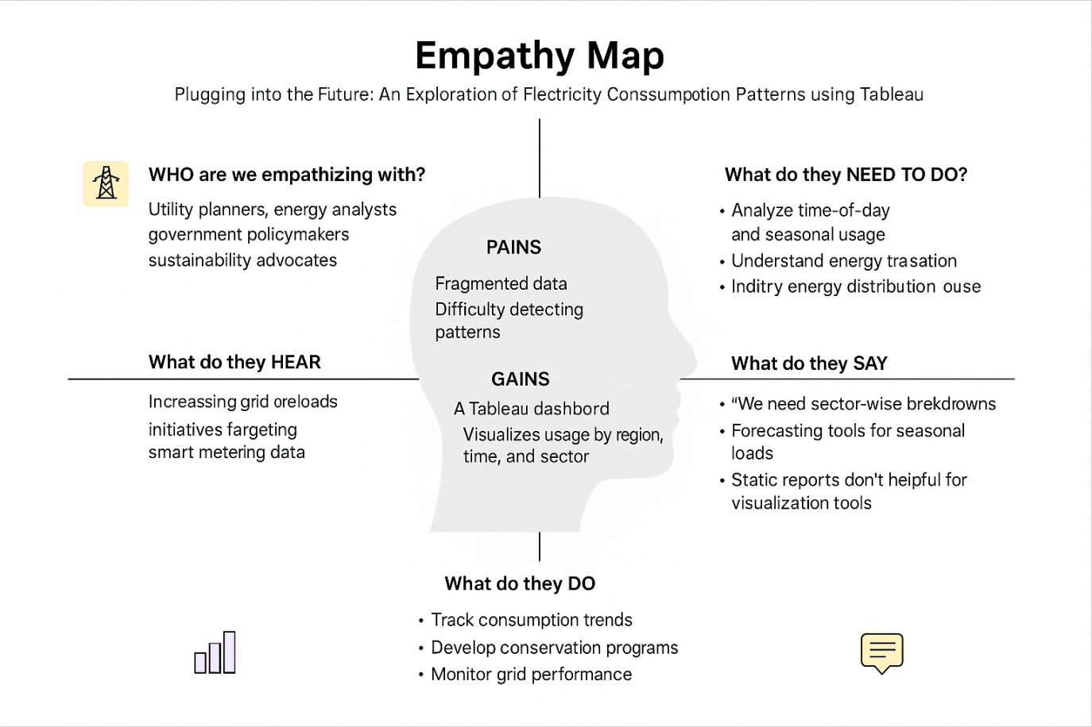

* 1. Brainstorming

Brainstormed Ideas:

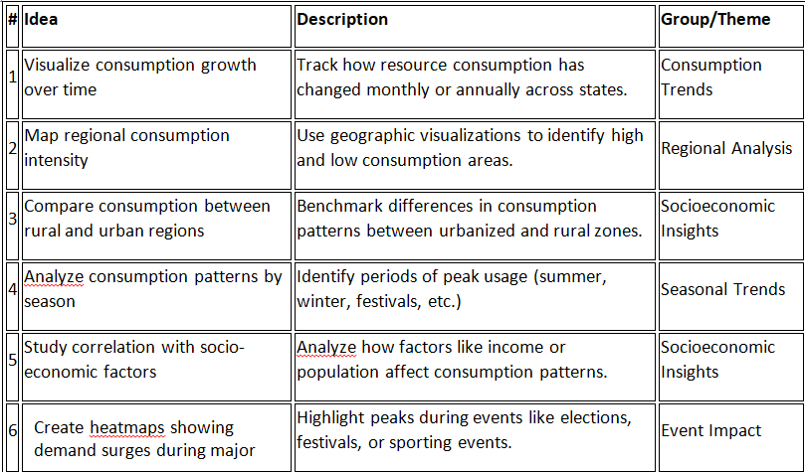

Idea Prioritization:

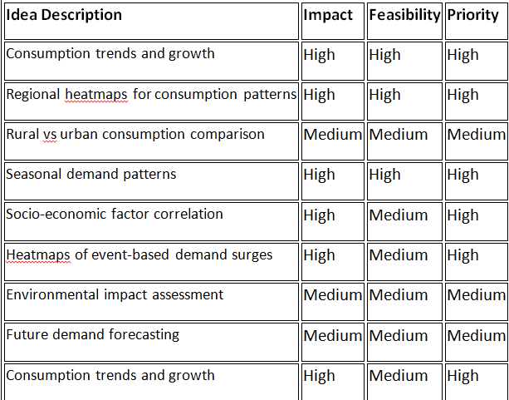

# REQUIREMENT ANALYSIS

* 1. Customer Journey map

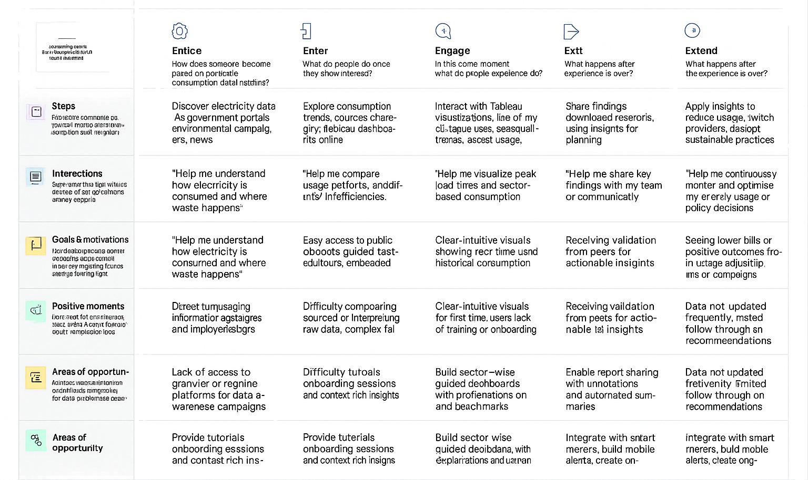

* 1. Solution Requirement

Functional Requirements:

Following are the functional requirements of the proposed solution.

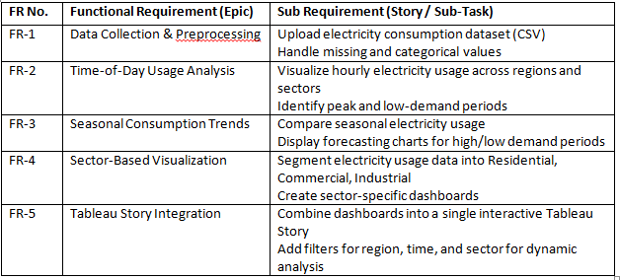

Non-functional Requirements:

Following are the non-functional requirements of the proposed solution.

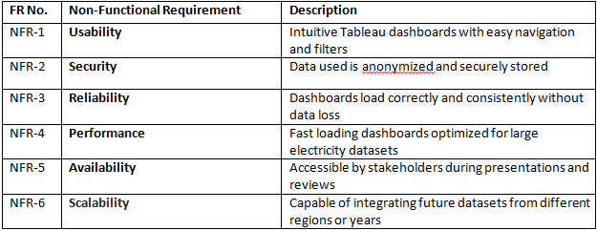

* 1. Data Flow Diagram

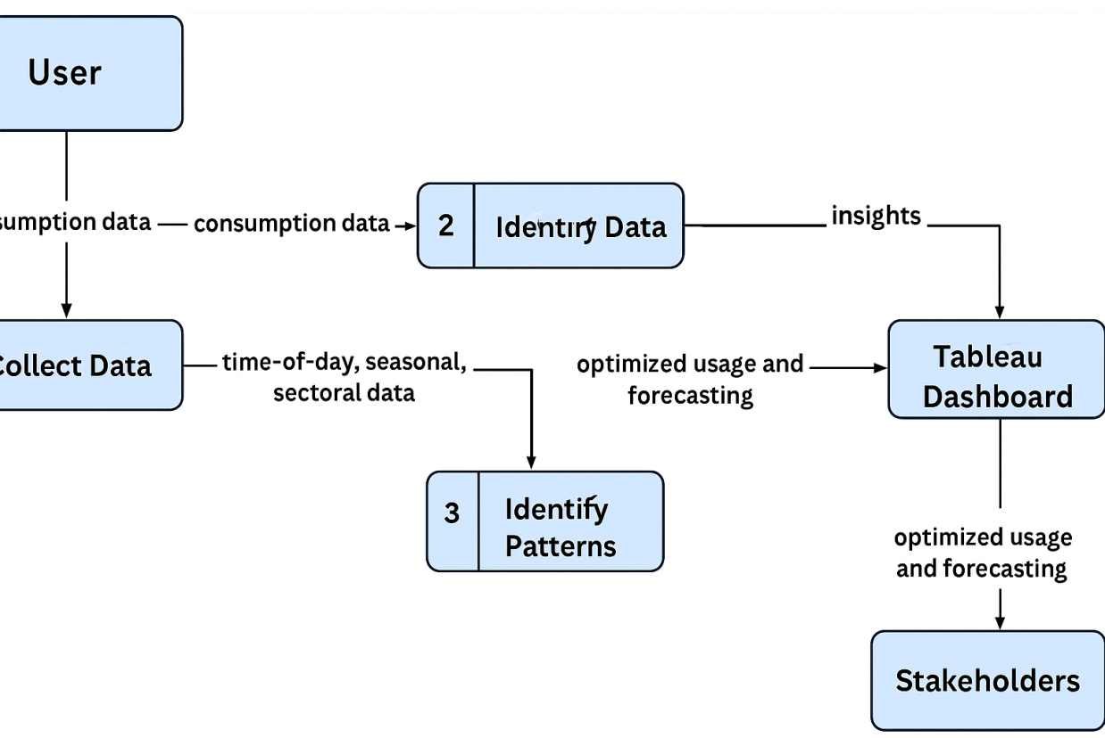

* 1. Technology Stack

.

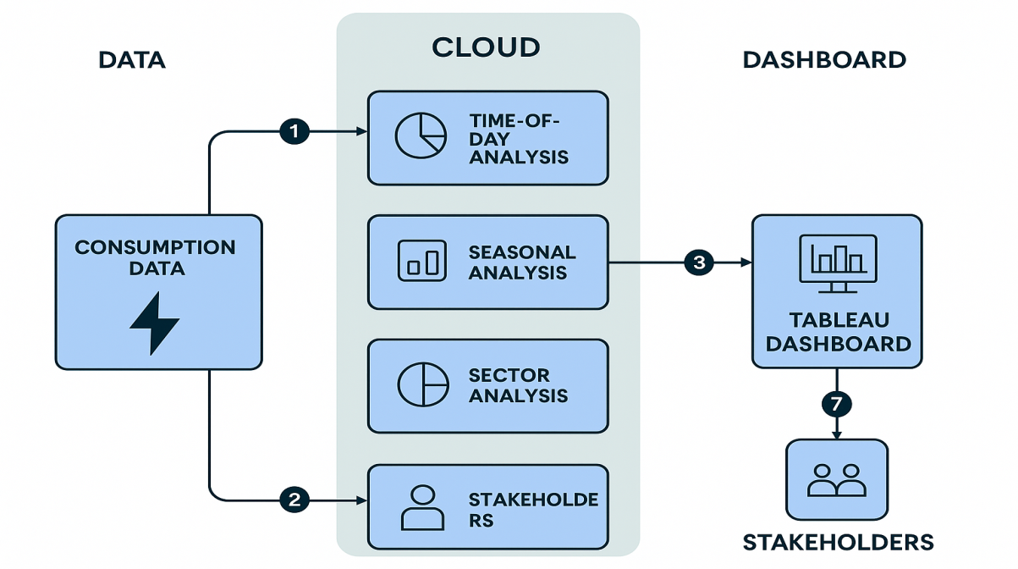

Table-2: Application Characteristics:

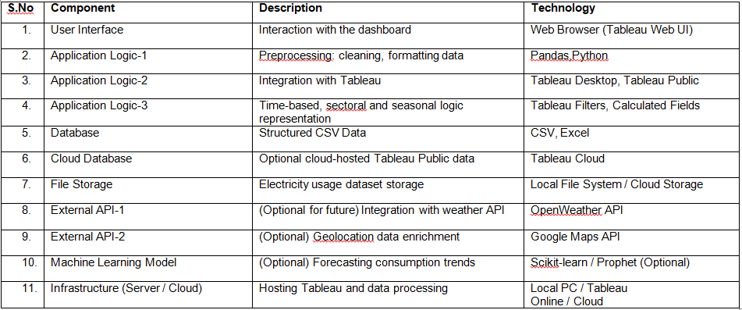

# PROJECT DESIGN

* 1. Problem Solution Fit

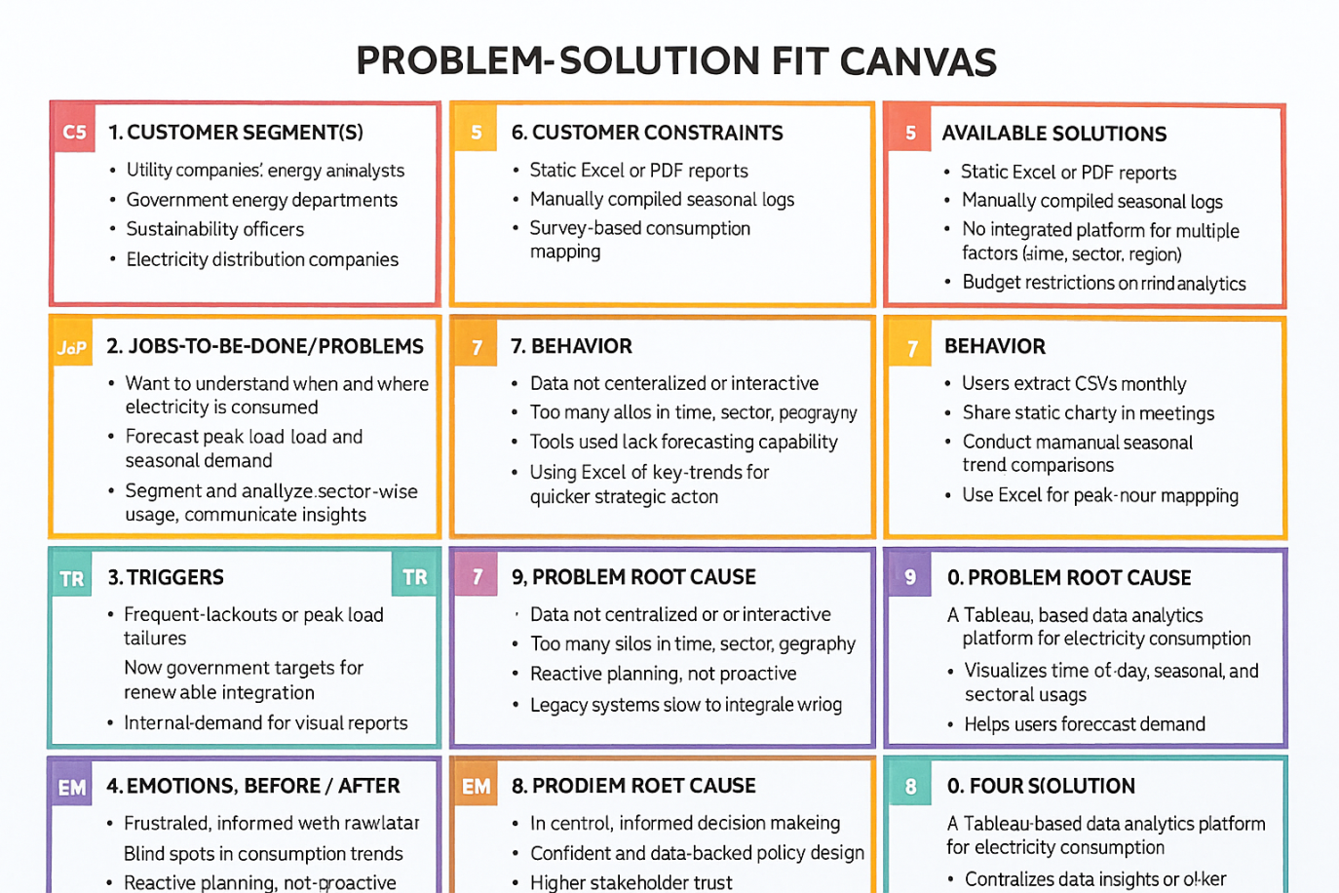

* 1. Proposed Solution

|  |  |  |
| --- | --- | --- |
| **S.No.** | **Parameter** | **Description** |
|  | Problem Statement (Problem to be solved) | Utility providers and policymakers lack clear, region-specific insights on consumption trends, seasonal demand, and socio-economic factors driving consumption, making resource planning inefficient. |
|  | Idea / Solution description | A Tableau dashboard that visualizes consumption data across Indian states and regions, tracking usage patterns over time, highlighting seasonal demand surges, and correlating them with socio-economic factors. |
|  | Novelty / Uniqueness | Combines regional consumption trends, demographic or seasonal overlays, and environmental considerations in a single interactive visualization platform tailored for India. |
|  | Social Impact / Customer Satisfaction | Supports better planning for electricity/utility infrastructure, ensures fair and efficient distribution, and improves customer satisfaction through data-driven demand management. |
|  | Business Model (Revenue Model) | Indirect revenue: Provides valuable analytics to utility companies, government agencies, and sustainability partners to optimize resources, reduce costs, and improve service quality. |
|  | Scalability of the Solution | The solution can be scaled to other countries, other utilities (like water, gas), or extended to even more granular household-level datasets by adapting the Tableau structure with localized consumption data. |

* 1. Solution Architecture

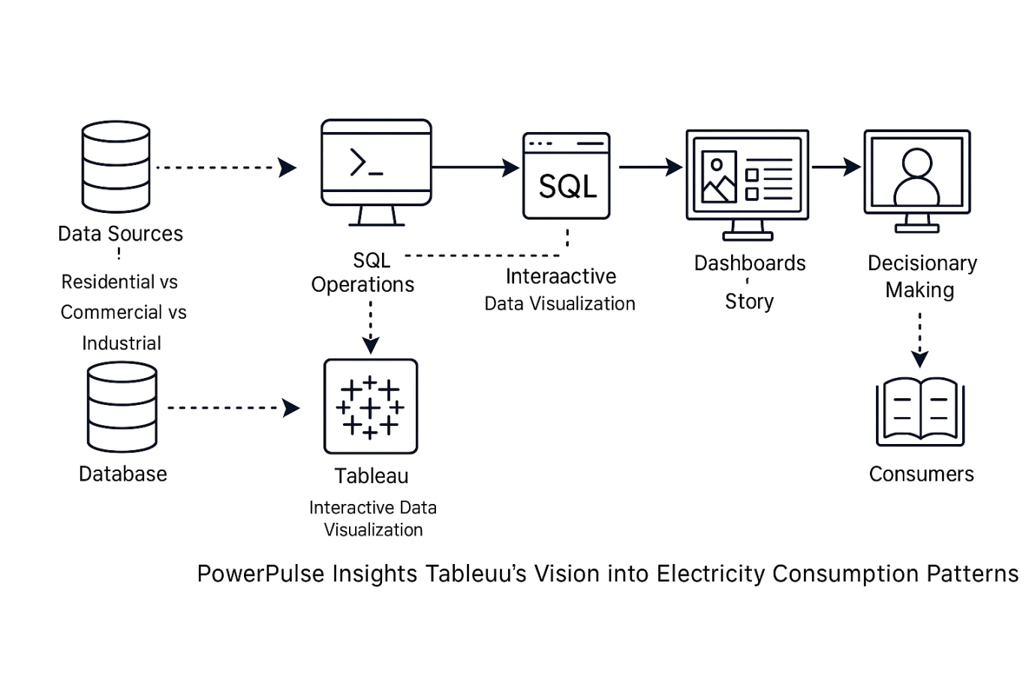

*Figure 1: Architecture and data flow of the plugging into the future: an exploration of electricity consumption patterns using tableau*

# PROJECT PLANNING & SCHEDULING

* 1. Project Planning

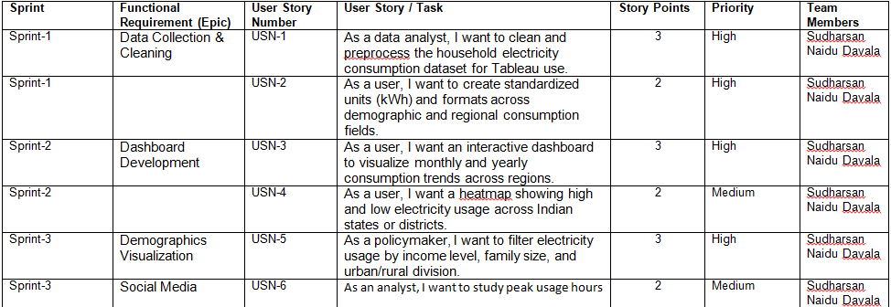

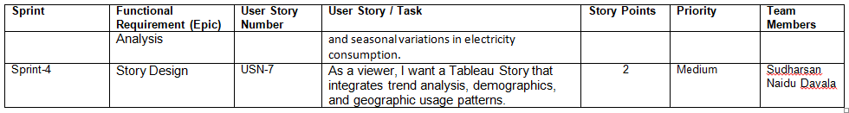

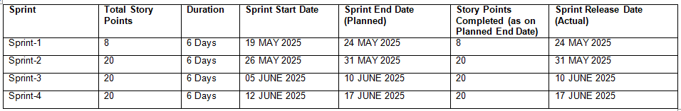

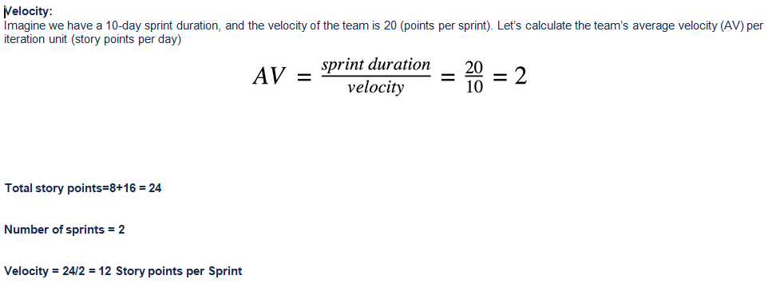

Burndown Chart:

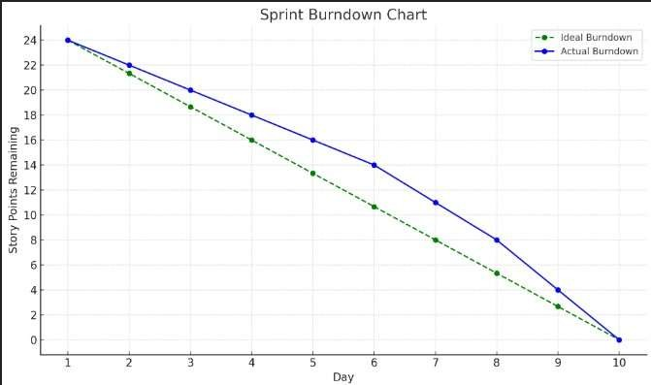

# FUNCTIONAL AND PERFORMANCE TESTING

* 1. Performance Testing

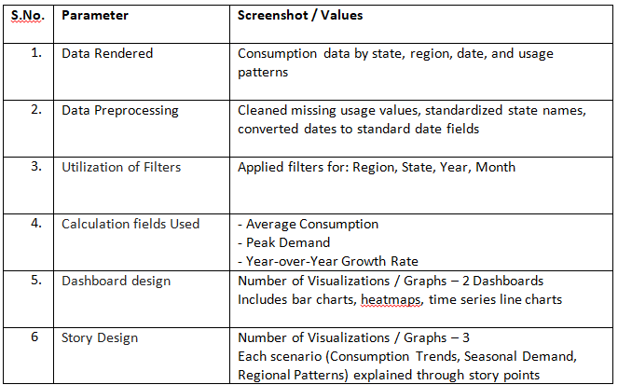

# RESULTS

* 1. Output Screenshots

Dashboard 1:

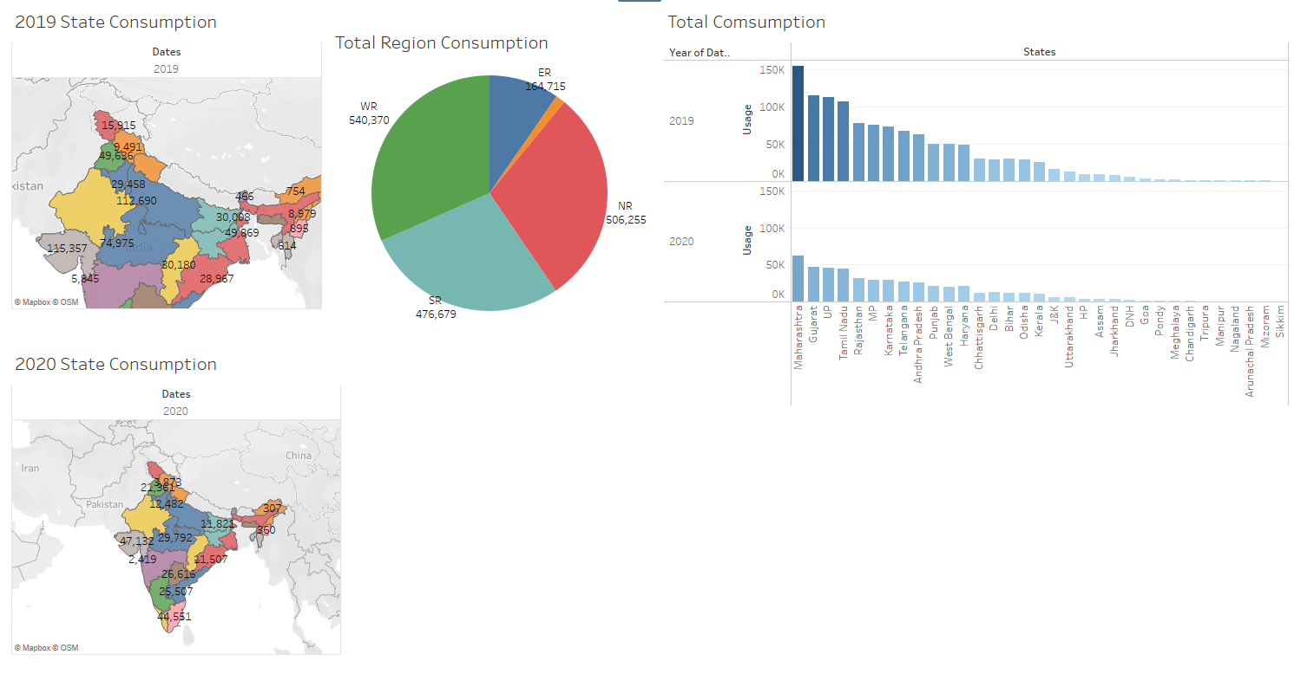

Dashboard 2:

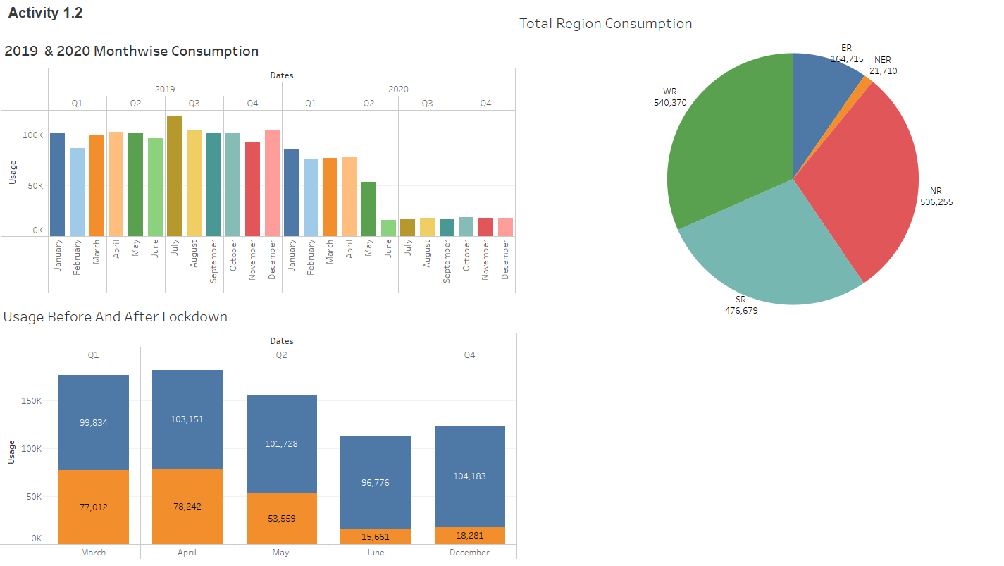

Dashboard 3:

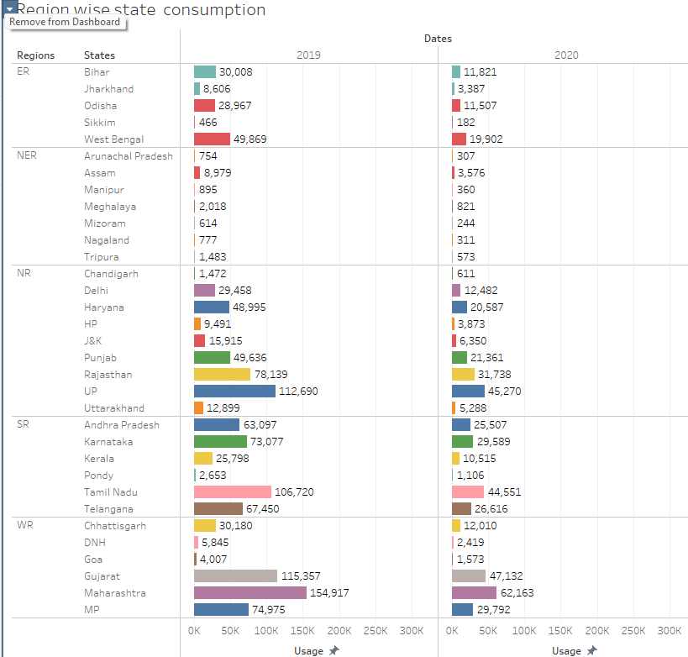

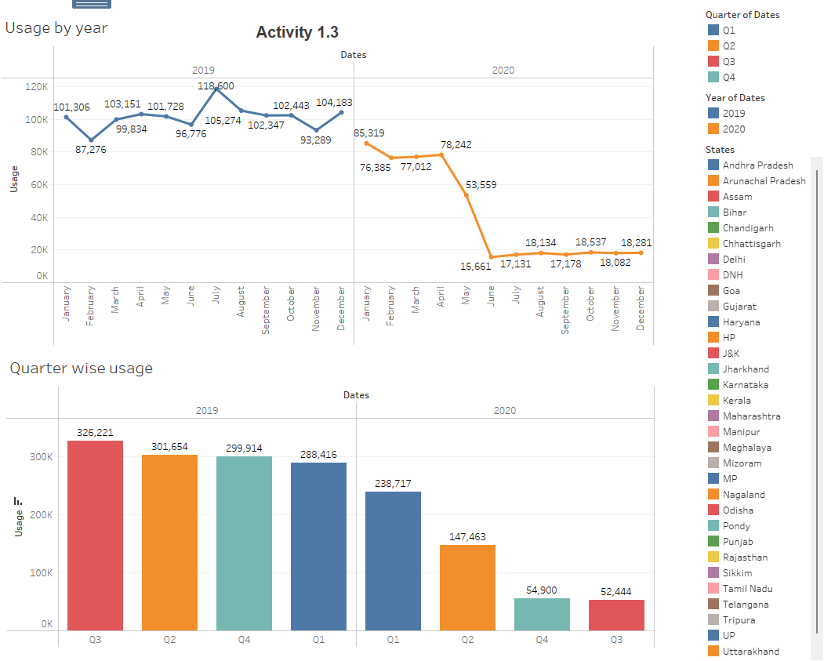

1. **ADVANTAGES & DISADVANTAGES**

**Advantages**

### **1. Enhanced Decision-Making through Visual Insights**

By transforming raw electricity usage data into clear, interactive visualizations, the project enables stakeholders to quickly understand trends and anomalies. This supports smarter, faster decisions by utility companies, policymakers, and energy managers.

**2. Improved Grid Management and Load Balancing**

Time-of-day and seasonal analysis helps utility providers identify peak demand periods and low-usage times, enabling better planning for energy distribution, load shifting, and infrastructure investment.

**3. Sector-Specific Energy Optimization**

By breaking down electricity usage by sector (residential, commercial, industrial), the project highlights which sectors are the most energy-intensive. This enables targeted efficiency programs and sector-specific conservation efforts.

**4. Support for Renewable Energy Integration**

Understanding seasonal and temporal demand patterns helps align electricity consumption with renewable energy production (e.g., solar and wind), making it easier to integrate renewables into the grid and reduce reliance on fossil fuels.

**5. Empowerment of Consumers and Policymakers**

The accessible visual format makes complex data understandable to non-experts, empowering consumers to make informed decisions about energy use and helping policymakers design more effective sustainability regulations and incentives.

**Disadvantages**

### **1. Data Availability and Quality**

The accuracy and effectiveness of the visualizations heavily depend on the availability of reliable, up-to-date, and high-resolution electricity consumption data. Incomplete or inconsistent datasets can lead to misleading insights.

**2. Limited Predictive Capability**

While Tableau excels at visualizing historical and current data, it has limited built-in capabilities for advanced forecasting or predictive analytics without external tools or manual integration with statistical models.

**3. Static Nature of Visualizations Without Live Data**

If the dashboards are not connected to real-time or frequently updated data sources, the visualizations may quickly become outdated, reducing their relevance for time-sensitive decision-making.

**4. Sector and Region Generalization**

Aggregated data might mask important sub-patterns within sectors or regions. For example, residential energy use may vary significantly by income level or climate zone, which may not be fully captured in broad visualizations.

**5. User Interpretation Risk**

Although Tableau simplifies data presentation, users without data literacy might misinterpret visualizations, draw incorrect conclusions, or overlook critical context, potentially leading to flawed decisions.

1. **CONCLUSION**

The project **“Plugging into the Future”** successfully demonstrates how data visualization tools like Tableau can be leveraged to uncover meaningful insights into electricity consumption patterns across time, seasons, and sectors. By analysing time-of-day usage trends, seasonal demand variations, and sector-specific consumption, the project provides valuable information for utility providers, policymakers, and energy-conscious consumers.

These insights support more efficient grid management, informed policy development, and the promotion of sustainable energy practices. Although the project faces certain limitations—such as dependency on data quality and limited predictive capabilities—the benefits of accessible, interactive, and actionable visual data far outweigh the challenges.

In an era where energy efficiency and sustainability are critical, this project highlights the importance of using visual analytics to guide smarter energy decisions. It sets the foundation for further exploration, including real-time data integration, predictive modelling, and more localized energy analysis, all of which can contribute to a more resilient and sustainable energy future.

1. **FUTURE SCOPE**

#### **1. Real-Time Data Integration**

Incorporating live electricity usage data from smart meters and IOT devices can enable real-time monitoring and decision-making. This would allow utility companies and consumers to respond dynamically to demand fluctuations.

#### **2. Predictive Analytics and Machine Learning**

Future enhancements could involve integrating predictive models using tools like Python or R alongside Tableau. This would help forecast future electricity demand based on historical patterns, weather data, and behavioural trends.

#### **3. Geographic and Demographic Expansion**

Expanding the dataset to include more granular geographic regions (e.g., neighbourhoods or zip codes) and demographic details (e.g., income levels, household size) can uncover deeper insights into localized consumption behaviour.

#### **4. Renewable Energy Correlation**

The project can be extended to analyze the relationship between electricity consumption and renewable energy production (solar, wind, etc.), helping to optimize the balance between demand and green energy supply.

#### **5. User-Focused Dashboards**

Developing customized dashboards for different stakeholders—such as policymakers, utility operators, and end-users—can improve usability and ensure that insights are tailored to specific needs and objectives.

1. **APPENDIX**

Dataset Link:

[Dataset](https://drive.google.com/file/d/1JxIkHNwXxjFztKq7ad0_KtkukCqTckNy/view)

GitHub & Project Demo Link: